**God the Creator**

**Reading: Genesis 1:1-5, 31**

God created the sky and the earth. At first, the earth was completely empty. There was nothing on the earth. Darkness covered the ocean, and God’s Spirit moved over the water. Then God said, “Let there be light!” And light began to shine. He saw the light, and he knew that it was good. Then he separated the light from the darkness. God named the light “day”. And he named the darkness “night”.

There was evening, and then there was morning. This was the first day.

God looked at everything he had made. And he saw that everything was very good.

**Thought about the reading**

God has lots of names in the Bible. These names describe what he is like. They can help us understand a bit about him.

The first name that is used is ‘Elohim’. This means that God is the eternal, powerful Creator.

Everything has a beginning. In the reading we heard that God created the sky and the earth. That was their beginning. Our beginning is on the day we were born. God does not have a beginning. He was always alive. That is what eternal means.

God also made me. In Psalm 139 it says:

“I praise you because you made me in such a wonderful way. I know how amazing that was!”

Let’s praise and thank God for his wonderful creation

**Prayer**

God the Creator, I am amazed at the wonderful world you have made. I thank you and praise you that it is so beautiful.

I thank you that you also made me and that you love me.

Amen

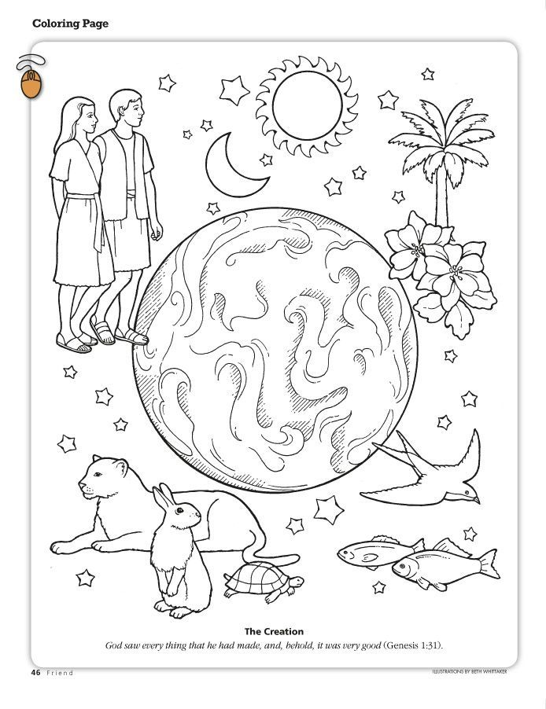

**Cambridge Causeway**

Spring 2022

Bible Study notes

**Names of God**

1. God the creator

By Chrissy Cole